
Program: CSE STAR C | Semester: IV
Course Name: WEB TECHNOLOGIES | Course Code: 23CSE404
Submission Date: 12/04/2026 | Year: II
Name: Vishrutha G | USN: 24BTRCT147
LAB EXERCISE 8

﻿﻿8. Perform Form Handling and Form validation for Exercise-1 &amp; 2 using PHP.

CODE:
Exercise-1 (Personal Website)
🔹 contact.html
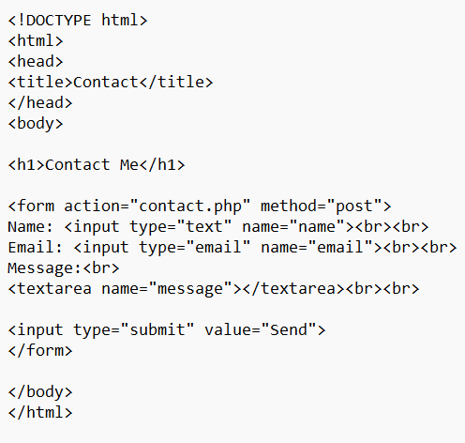

🔹 contact.php

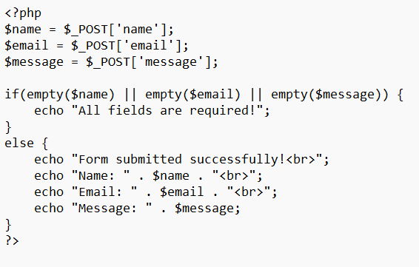

Exercise-2 (E-Commerce Website)
🔹 order.html
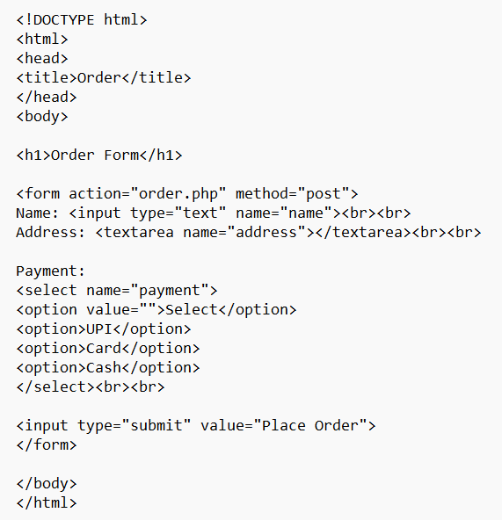

🔹 order. php

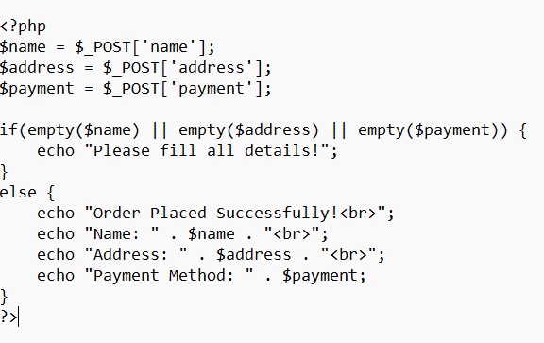

OUTPUT:

